Green Society Public School
D-17
Ratnanagar-7, Sauraha, Chitwan
Annual Examination-2082
Class: Three Time: - 1 hr. F.M.: 25
Sub: Computer
Name: Roll No.: Sec.:
________________ ______________ OBT.MARKS:
INVIGILATOR EXAMINER
- Fill in the blanks [4×1=4]
Turtle, keyboard, soft copy, speed
a. Computer works at a very high ________________.
b. The output shown on the monitor is called ___________.
c. _____________ is used to enter data and instruction into computer.
d. _____________ has a pen that follows the commands and draw shapes.

- Write 'T' for true or 'F' for false in given statement. [4×1=4]
a. CPU is fixed inside the system unit.
b. Taskbar is located at the bottom of the desktop.
c. Rectangle Tool is used to draw straight, wavy and curved lines.
d. The pause button stops the execution permanently.

- Match the followings [4×1=4]
Column A Column B
Icons The automatic placement of word in
the next line.
Word wrap The small pictures that appear on the
desktop.
Cleartext Move the head of the turtle to right
direction.
RT Clear the text screen.

- Identify the following picture [5×1=5]
Monitor | Mouse | CPU | Speaker | Keyboard

- _____________ b. ______________

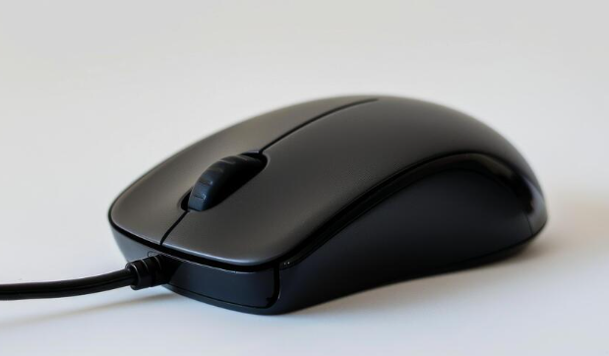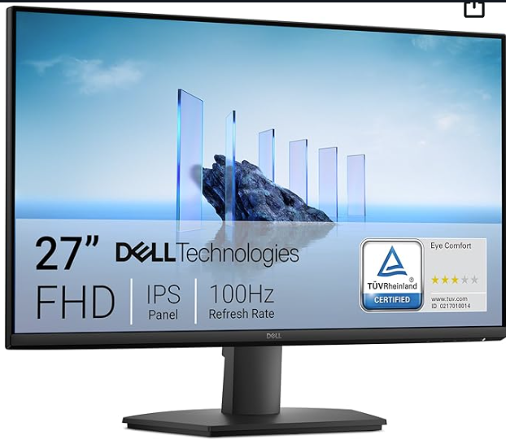

- __________________ d. ______________

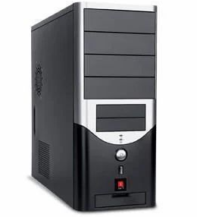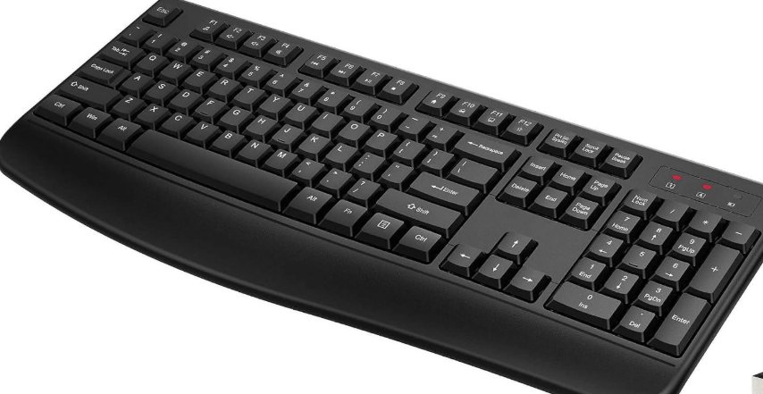

e_________________________

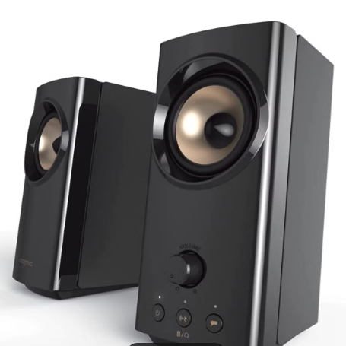

- Answer the following question [4×2=8]
a. What does the word "computer" mean?

______________________________________________________

______________________________________________________

- What does color box indicate?
_____________________________________________________

_____________________________________________________

- What is a word wrap?

_____________________________________________________

_____________________________________________________

- Why do we use RT and LT commands?

_____________________________________________________

_____________________________________________________

The End

